The Pros and Cons of Franchise Ownership
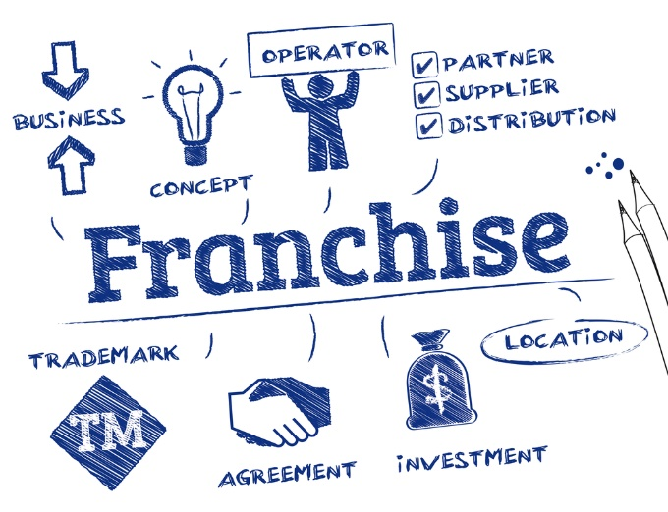
Franchise opportunities are more structured than business opportunities. If thinking of purchasing a franchise, just like with any business venture, there are pros and cons of franchise ownership. For instance, purchasing a franchise can be a little more expensive than buying a business, but it comes with a ton of "built in trial and error work" that you will not need to do. Someone else has pioneered that trail for you.
It is true; generally, buyers operate under their own name not featuring the seller's trademark, run their business the way they want and call all the shots. In the case of a franchise, with the initial fee you pay, along with future royalties, you gain the advantages of using the franchisor's brand, trademark, logos, operating systems, signage, expensive demand generation marketing and other marketing practices - website with B2B content creation, real-world content creation and lead generation to name a few.
Support being a phone call or email away is another huge asset for a franchisee. For an owner of a business, there is no ongoing support from the previous business owner making you the responsible proprietor; basically. you are on your own. As the owner of a franchise, however, there is continuous support from the franchisor and you are able to utilize their existing operations system and sell their services or products; and you also have use of a proven track record and training program. With both a business and franchise purchase, both may or may not require lead generation, but most certainly will involve demand generation. So, should you buy a business or franchise?
- Franchise Facts – Murphy Business’ interesting franchise facts and statistics.
- Franchising Industry Statistics – Provides information on USA franchising business.
- Lead Generation – How to build a lead generation machine at startup.
- The Daily Egg– The truth about b2b lead generation – what really works?
- Encyclopedia.com – What is franchising?

The Pros of Franchise Ownership:

Unlike a business purchase, many benefits come with the purchase of a franchise. The purchaser does not have to "go it alone" and start all business aspects from the ground level, essentially getting a business package.
- Business failure risk is lower, with trial and error almost non-existent. A franchise is "tried and true" with business mistakes fixed going in. This is a big deal when you think about daily operations, how many employees are needed - on what days and what hours for each. How to train new employees and retrain existing ones whose performance may be lacking. How much product needs to be sold to sustain the franchise or to make a profit. How to market effectively - what strategies should be used? The franchise already effectively uses demand generation for marketing. Most likely, a website exists where specific content creation and b2b content creation have been strategically written to optimize the sites information. so this is a big plus.
- Franchisee gets the power of a pre-existing Brand's trademark.
- Franchisee does not start from scratch, all products and services are pre-existing. Franchises already exist in the marketplace and have a verifiable performance record. A franchisee benefits from all the hard work of their franchise predecessors.
- Local and/or national marketing exists.
- Franchisee has access to the franchise business operating system to run their business. This is a huge benefit because you do not have to enter all the products or services, or program a system to do what you need it to.
- Company documentation is already in place.
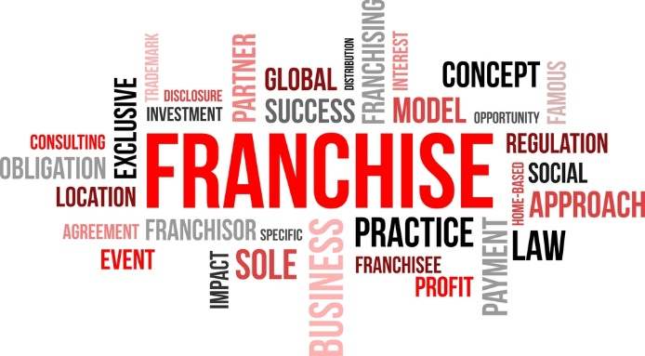
- Tested training programs that work for the franchise are already in place.
- Ongoing support system from the franchisor is in place and included with the purchase.
- What is Demand Generation? – Explanation of demand generation.
- ForSee – The art and science of measuring customer experience.
- iResearchServices Applied Intellect – Four ways to avoid common lead generation mistakes.
- Noodle – Bad stories about education lead generation companies and what a consumer should be aware of.
- American Bar Association – Understanding franchise law.

The Cons of Franchise Ownership:

When considering the purchase of a franchise, do not let the excitement of owning one influence your decisions. Do not let impulses control how you proceed without the proper planning for success.
Strict guidelines and expectations are par-for-the-course, and hard-driven independent entrepreneurial personalities may find it hard to adapt to the restrictions of a franchise. If you prefer things to be done your way or it's the highway, then you might want to consider a business purchase where you have complete control. It is a good idea to hire an experienced CPA to help you set up a good cash-flow projection and to better control expenses.
- Just like there are strong franchises, weak ones are for sale to. There could be organizational issues, poor training, lack of communication, a poor support system, or any number of negatives.
- Your advertising dollars may not be used efficiently or effectively.
- Forfeit of business control personally. Rules and guidelines are in place and must be followed precisely.
- A franchisor's problems are your problems too. You are the face of the company to the public. When they are not happy with the Brand, they are not happy with you.
- You sign an ironclad, binding contract.
- Franchise Disadvantages – Top seven disadvantages to buying a franchise.
- International Franchise Association – What are the advantages and disadvantages of owning a franchise?
- Queensland Government Business and Industry Portal– Advantages and disadvantages of buying a franchise.
- Content Marketing Institute– New research on what effective B2B content marketing looks like.
- Entrepreneur – 35 content marketing statistics you need to know in 2016.

Associated Costs:

- Location - In some cases, you may be required to rent a facility, or buy a building or land (which could mean putting up a building for your franchise.) Renting a building means you are solely responsible for any security deposit and the monthly lease. However, the franchisor might include an allowance of roughly $10,000 to $15,000 for improvements.
- Equipment - All businesses are different and need their specific equipment. Generally, for equipment there are long-term payment plans available. Most banks use the equipment as collateral and extend loans.
- Signs - Signage needed - inside and outside - can be costly for the small business owner. Fortunately, the obligation to purchase and supply these is on the franchisor.
- Advertising Fees - The cost for regional and/or national advertising is usually an added expense. Bigger franchises require the franchisee to pay a specific amount in advance for national advertising used to advance their concept. The benefit of this is substantial visibility for your business. It not only puts you on the map, but keeps you there. Marketing can include things such as demand leads that are marketing-centric; focus is not only on your offerings, but your industry too covering all aspects about your products/services, the company and the industry.
Big franchisers most likely have a website, which technically means so do you. B2B content (business to business) and strategic website SEO content creation is part of the Brand's marketing. A website also means lead generation and collecting emails from people looking for your products and/or services.
Even though the franchise most likely provides marketing (at your expense), it does not mean you cannot take the initiative to do your own marketing. Regional and national if applicable, lead generation and demand generation are two things you can facilitate to increase traffic, business and profits on your own.
- Entrepreneur – Top 10 reasons to buy a franchise.
- Inc. – Advantages of buying a franchise over an independent business.
- Small Business – The advantages of owning a franchise.
- Small Biz Trends – Often overlooked benefits of franchise ownership.
- Business.com – Two sides of content – lead generation versus demand generation.

